

**Department of Electrical and Computer Engineering**

| Course Number | CPS510 |
| --- | --- |
| Course Title | Database Systems I |
| Semester/Year | F2022 |
| Instructor | Dr. S. B. Tajali |
| Lab Section | 7 |

| Assignment No. | 4b |
| --- | --- |
| Assignment Title | Assignment 4b: Views and Queries |

| Submission Date: | October 17, 2022 |
| --- | --- |
| Due Date: | October 17, 2022 |

| Student Name | Ethan Moo-Young | Ernestine Ho | Abel Abraham Thomas |
| --- | --- | --- | --- |
| Student ID | 501016708 | 501022253 | 501029194 |
| Signature |  |  |  |

Contents of [Book] Table

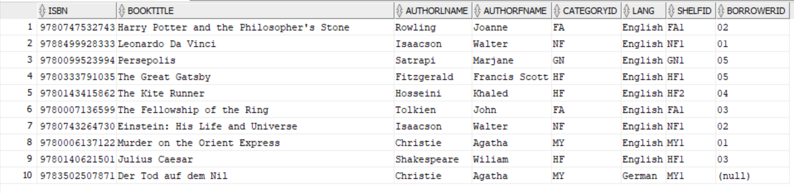

Contents of [Category] Table

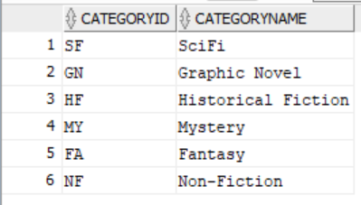

Contents of [Client] Table

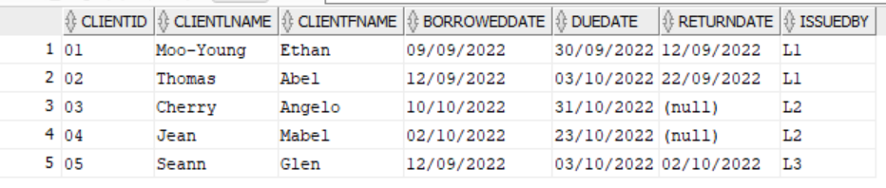

Contents of [Shelf] Table

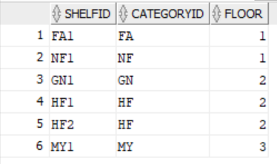

Contents of [Staff] Table

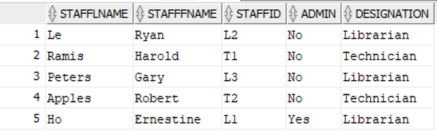

**Views**:

A View table for Client to check what books are available in the library:

| CREATE VIEW available_books AS  (SELECT isbn, booktitle, authorfname, authorlname  FROM book  WHERE booktitle IS NOT NULL); |
| --- |

Views table Result:

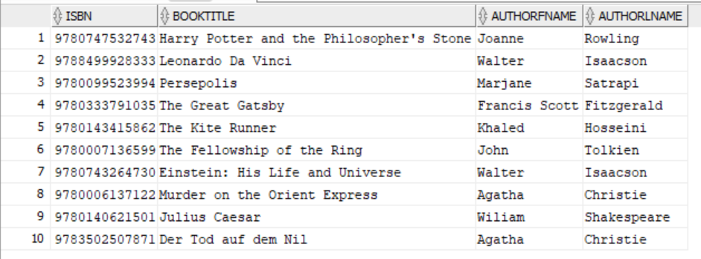

A View table for owner to see which staff has admin status:

| CREATE VIEW staff_admin_status AS  (SELECT stafflname, stafffname, admin  FROM staff  WHERE stafflname IS NOT NULL AND stafffname IS NOT NULL); |
| --- |

Views table Result:

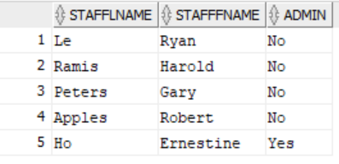

A View table for staff to see which books are not returned yet:

| CREATE VIEW unreturned_books AS  (SELECT isbn, booktitle, borrowerid, duedate  FROM book, client  WHERE client.returndate IS NULL AND book.borrowerid = client.clientid); |
| --- |

Views table Result:

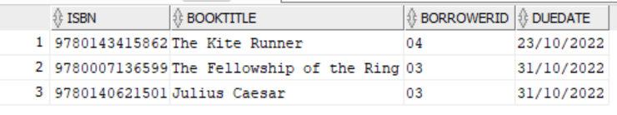

A View table for staff to see statistics of time clients takes to return book after borrowing:

| CREATE VIEW client_borrowtime AS  (SELECT clientlname, clientfname, borroweddate, returndate, ROUND(returndate - borroweddate) AS total_time  FROM client  WHERE clientlname IS NOT NULL AND clientfname IS NOT NULL); |
| --- |

Views table Result:  
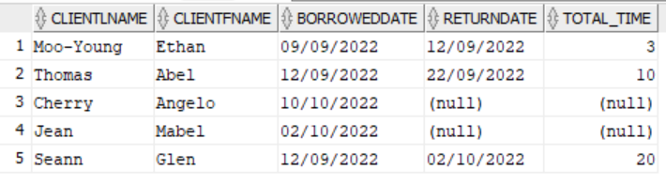

**Queries**:

Books borrowed by clients in the month of September:

| SELECT isbn, booktitle, borroweddate FROM book, borrowedbooks, client WHERE book.borrowerid = client.clientid AND EXTRACT(MONTH FROM borroweddate) = 9 ORDER BY borroweddate ASC; |
| --- |

New(tested):

SELECT b.isbn, b.booktitle, bb.borrowerdate

FROM book b, borrowedbooks bb, client

WHERE bb.borrowerid = client.clientid AND b.isbn = bb.isbn AND EXTRACT(MONTH FROM borrowerdate) = 9 ORDER BY borrowerdate ASC;

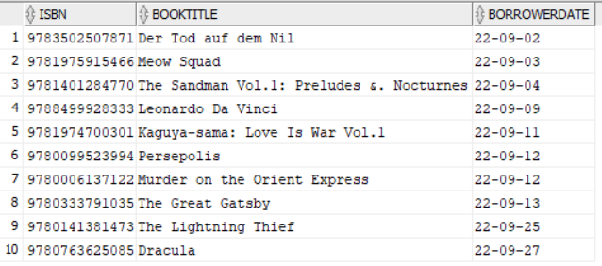

Old Query Result:

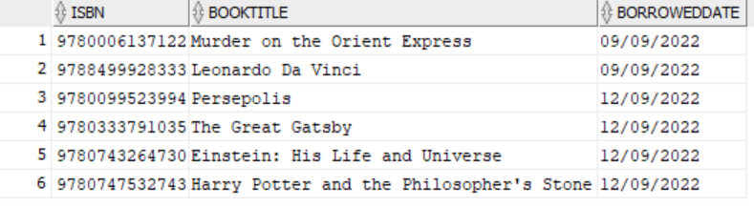

Books borrowed by Glen Seann:

| SELECT isbn, booktitle, clientid from book b, client c WHERE b.borrowerid = '05' AND c.clientid = '05'; |
| --- |

New(tested):

SELECT b.isbn, b.booktitle, bb.borrowerdate from book b, client c, borrowedbooks bb

WHERE b.isbn = bb.isbn AND bb.borrowerid = '05' AND c.clientid = '05';

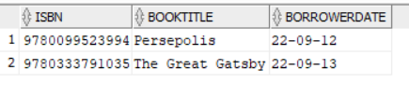

Old Query Result:

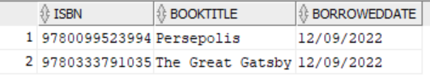

Floor Number of fantasy books:

| SELECT isbn, booktitle, floor FROM book b, shelf sh WHERE b.categoryid = 'FA' AND b.shelfid = sh.shelfid ORDER BY booktitle ASC; |
| --- |

New(tested):

SELECT isbn, booktitle, floor FROM book b, shelf sh WHERE b.categoryid = 'FA' AND b.categoryid = sh.categoryid ORDER BY booktitle ASC;

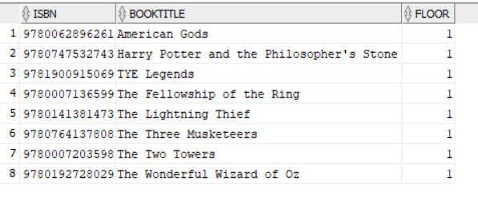

Old Query Result:

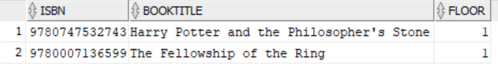

Select Distinct clients with borrowed books and which staff helped the client:

| SELECT DISTINCT clientlname, clientfname, stafffname || ' ' || stafflname AS helped_by FROM client c, book b, staff s, borrowedbooks bb WHERE bb.returndate IS NULL AND bb.borrowerid = c.clientid AND c.issuedby = s.staffid; |
| --- |

New(tested):

SELECT DISTINCT clientlname, clientfname, stafffname || ' ' || stafflname AS helped_by

FROM client c, book b, staff s, borrowedbooks bb

WHERE bb.returndate IS NULL AND bb.borrowerid = c.clientid AND bb.issuedby = s.staffid;

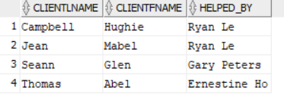

Old Query Result:

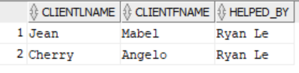

Books that have been borrowed by a client:

| SELECT book.isbn, book.booktitle, book.borrowerid, client.clientid, client.clientlname, client.clientfname from book INNER JOIN client ON book.borrowerid = client.clientid ORDER BY clientid; |
| --- |

New(tested):

SELECT book.isbn, book.booktitle, borrowedbooks.borrowerid, client.clientid, client.clientlname, client.clientfname from book, borrowedbooks, client WHERE book.isbn = borrowedbooks.isbn AND borrowedbooks.borrowerid = client.clientid ORDER BY clientid;

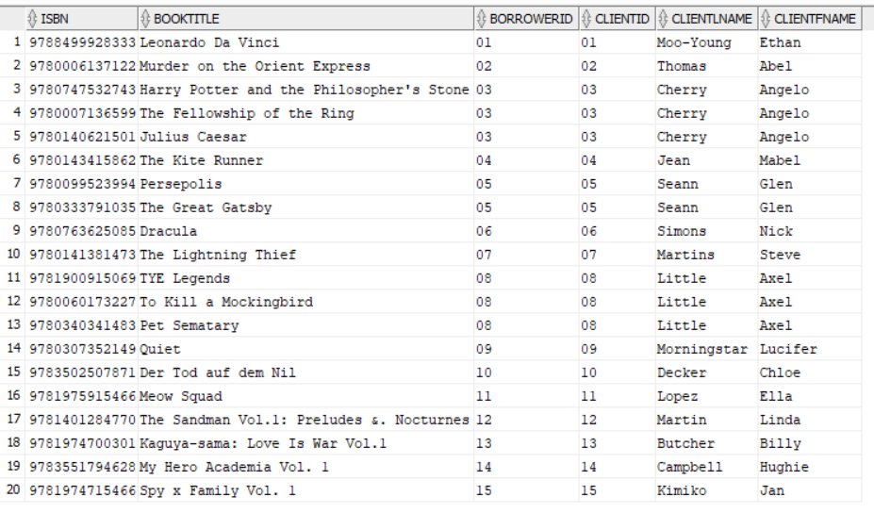

Old Query Result:

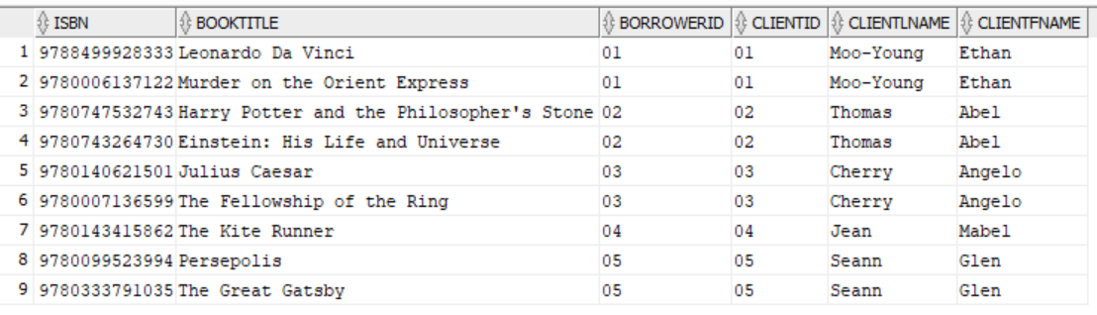

Select all the shelfs where floor is 1:

| SELECT shelfid, floor  FROM shelf  WHERE floor = '1'; |
| --- |

Query Result:

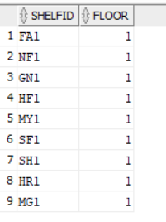

Books by author Agatha Christie:

| SELECT isbn, booktitle, authorlname, authorfname, lang, book.categoryid, categoryname  FROM book, category  WHERE book.categoryid = category.categoryid AND authorlname = 'Christie' AND authorfname = 'Agatha'; |
| --- |

Query Result:

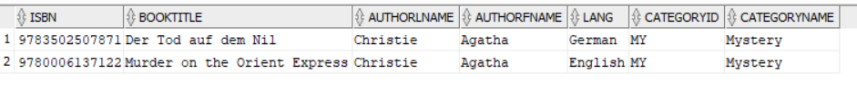

LIbrarian issuing book/books to a client (with the book and borrowing date):

| SELECT receiptid,issuedby, clientid, clientlname, clientfname, booktitle, borrowerdate  FROM borrowedbooks bb, client c, book b  WHERE bb.borrowerid = c.clientid AND b.isbn = bb.isbn ORDER BY receiptid; |
| --- |

Query Result:

